PRIORITY ORDER IN CASE OF TICKET SOLVING
1. Apply filter - open, assigned to me, oldest first, high to low priority, team name
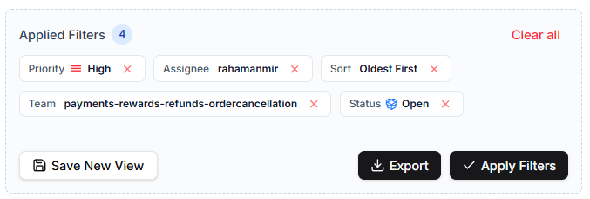
Within a specific team, if high priority tickets are solved or there is none, go to medium.
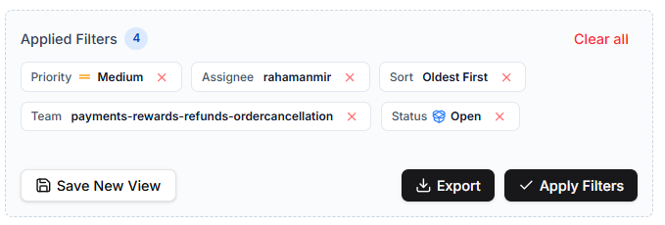
If medium ones are solved or there is no medium as well, go for low priority.
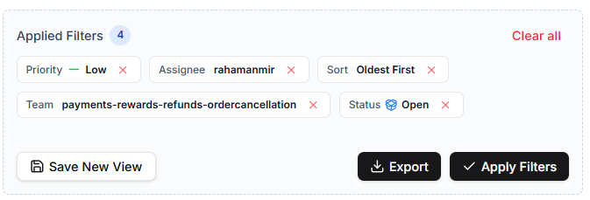
If there is no low priority or all are solved, go for next team as per the order below and follow the same steps for each team.
2. Among various tabs assigned to me, follow the below order for solving tickets-
i) payments-rewards-refunds-ordercancellation (customers who mistakenly placed order twice, now wants refund)
ii) payments -rewards-refunds (store credit, refund for damaged or missing items)
iii) post-delivery (checking whether product got damaged or not, what is the missing item)
iv) in-transit (tracking the parcel)
v) B2b (Business to business)
vi) No team (Remove any team filter)
vi) Instagram
vii) Whatsapp
if for anyone, any of the above team ticket is null, move to next one.
**For CE team, at EOD (6 pm), number of tickets in following tags - account issue, address queries, coupon and store credit, gardening tips, product info, reship, payment issues must be ZERO**

